A ‘Out of memory’ wall.

Programming models:
- Synchronous event loop: Coordination. Uses a single, large iteration to handle coordination. Invokes appropriate handlers within the loop

- Asynchronous event handlers: The hardware is configured to invoke an handler for each event. ( These are not coordinated as they are in single event loop)

- Concurrent execution: Software is organized as a set of programs that each operates concurrently. Each application ‘runs to completion’, runs until it chooses to stop. This is a powerful programming condition.

Is concurrent computation possible even if a computer has a single core ? Although many processors incorporate some parallelism, they create an illusion called, multitasking. The operating system switches the available processor(s) among multiple programs allowing the processor to execute one program for only few milliseconds before moving to the next one.

Terms:
- Process, or job, single computation self contained in a separate memory region that other processes cannot access
- Task refers to a statically declared process, like a function declaration
- Thread, a type of concurrent process that shares an address space with other threads. They can share information efficiently.

A program consists of code executed by a single process of control. In contrast, concurrent processes are not uniquely associated with a piece of code; multiple processes can execute the same code simultaneously.

Although processes share code and global variables, each process must have a private copy of local variables.

Storage for local variables, function argument, and a function call stack is associated with the process executing a function, not with the code for the function. The OS must allocate additional storage to each process, even if the process shares the same code with others. Therefore, the amount of memory available limits the number of processes that can be created.

Statically scoped language like C uses a running stack to store the state associated with a function call. The compiler allocates enough space on the stack to hold an activation record for the called function, the allocated space is known as stack frame. Each activation record contains space for the local variables allocated with the function, temporary storage needed during computation , a return address, etc. The compiler computes the size needed for local variables and temporary space for auxiliary items like registers, that can be used for the computation.

On an Intel processor, before invoking a function, a caller pushes EAX, ECX and EDX on the stack, pushes arguments in reverse order, and the executes a call instruction, which pushes the return address on the stack (this is removed by the return instruction). Code in the call function pushes EBP, EBX, and ESI registers, and pushes space for local variables. When the call returns, values are popped from the stack in reverse order.

A C compiler divides a RAM memory image in contiguous regions:
- Text segment: begins at the lowest usable memory address, contains compiled code for each of the functions (including code for main , which is compiled and linked like other functions). Addresses in this segment are classified as read-only if the hardware includes a protection mechanism.

- Data segment: contains storage for all global variables that are assigned an initial value. This segment is classified as read-write.

-Bss segment: contains global variables not initialized explicitly.

- Free space: addresses beyond the Bss segment are considered free (unallocated) when execution begins)

Text + Data + Bss segments contain the full program code.

The remaining memory can be allocated dynamically:

- Stack: each process needs space to hold the activation records associated with each function the process invokes. In addition to arguments, the activation records contains storage for local variables.

To summarize the stack:
- the stack grows and shrinks as functions push and pop local variables
- there is no need to manage the memory yourself, variables are allocated and freed automatically
- the stack has size limits defined at compile time
- stack variables only exist while the function that created them, is running

- Heap: items are allocated dynamically and persist independent of specific function calls. This region is not managed automatically for you, and is not as tightly managed by the CPU. It is a more free-floating region of memory (and is larger). To allocate memory on the heap, you must use malloc() or calloc(), which are built-in C functions. Once you have allocated memory on the heap, you are responsible for using free() to deallocate that memory once you don't need it any more. If you fail to do this, your program will have what is known as a memory leak. That is, memory on the heap will still be set aside (and won't be available to other processes).

USEFUL COMMANDS:

compile:
$ gcc -o turbo turboCMain.c

general heap memory info:
$ valgrind --tool=memcheck ./turbo

detailed heap memory info:
$ valgrind --xtree-memory=full --xtree-memory-file=xtmemory.kcg M./turbo

visualization of heap memory info:
$ callgrind_annotate --auto=yes --inclusive=yes --sort=curB:100,curBk:100,totB:100,totBk:100,totFdB:100,totFdBk:100 xtmemory.kcg

massif heap and stack profile:
$ valgrind --tool=massif --stacks=yes ./turbo

memory segments:
$ size turbo

Memory Profile Examples With Stack: 25 Cardinality

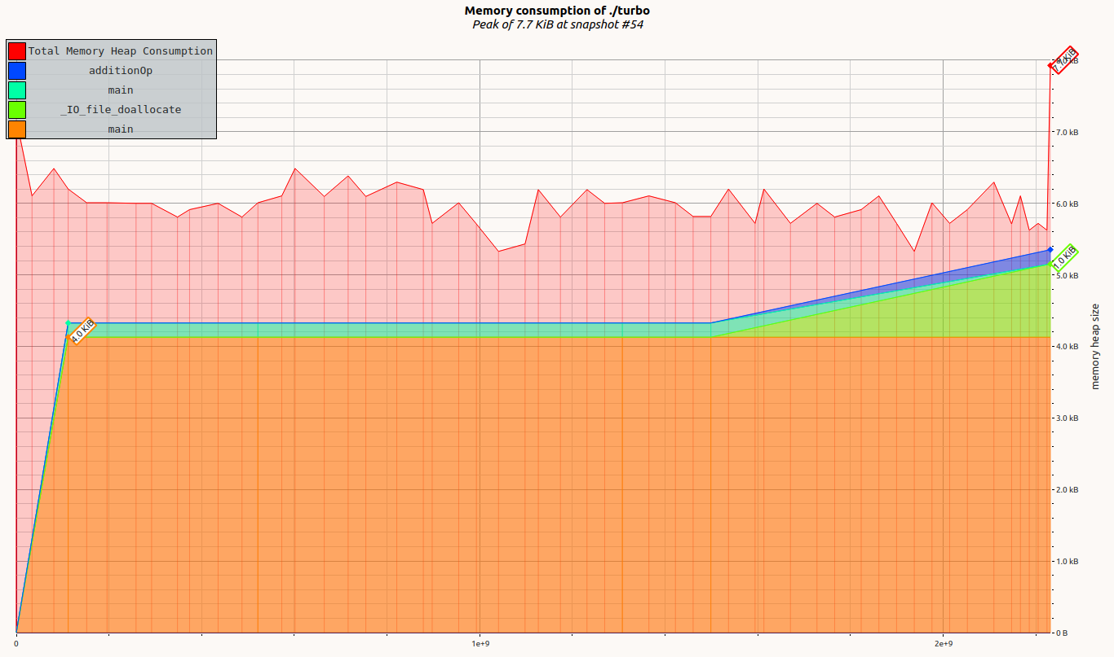

Memory Profile Examples With Stack: 30 Cardinality
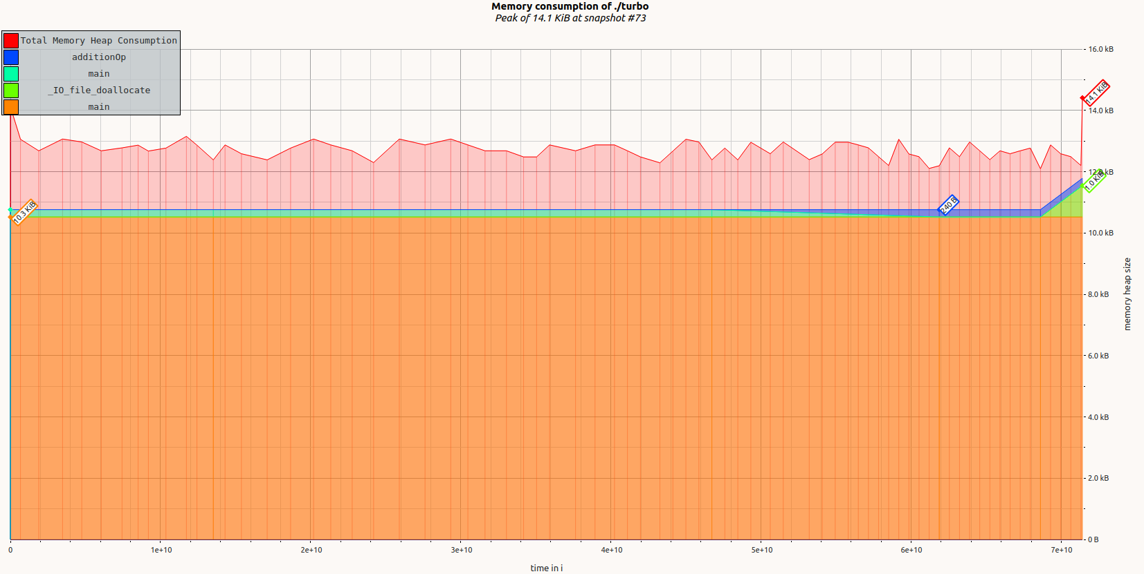

Comparison on memory peak, KB (stack and heap) and memory used at exit, KB (heap)

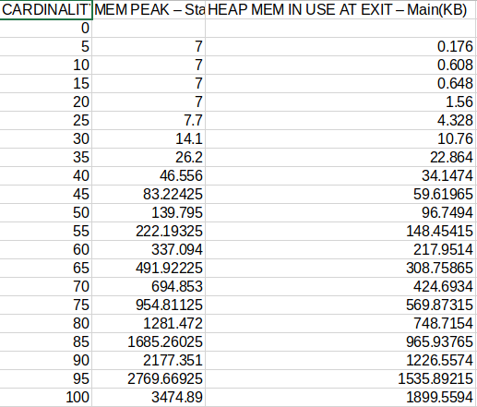

Comparison of total accumulated memory consumption for recursive process and main (KB) and the net memory consumption (KB)

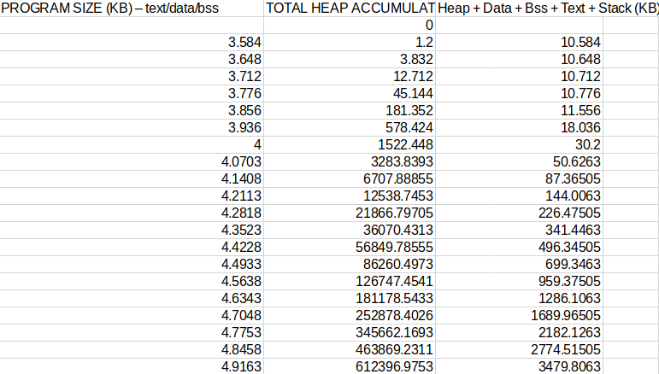

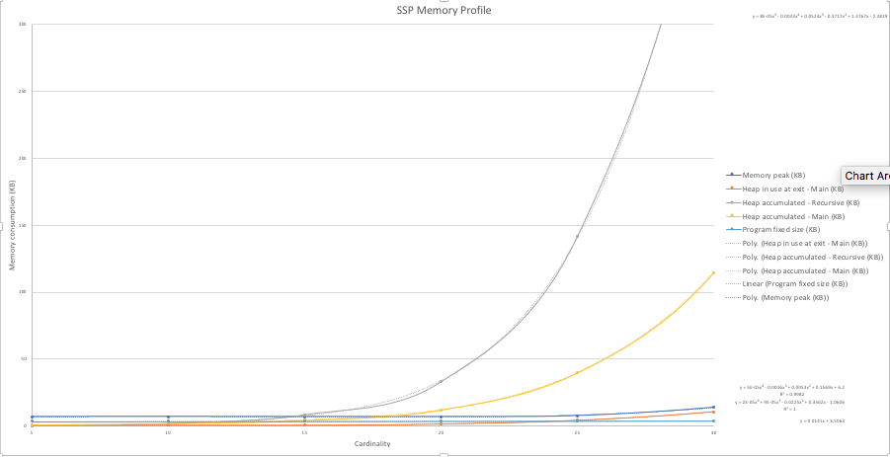

Memory peak, Heap in use at exit, program fixed size and accumulated heap for main and recursive process, all in KB, all NON EXTRAPOLATED

Accumulated Main and Recursive process, and Net all segments memory profile

